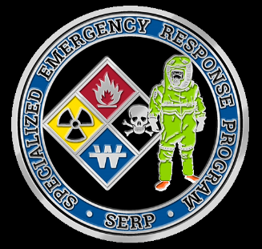**Specialized Emergency Response Program**

**of Whatcom County**

**Hazardous Materials Unit**

PO BOX 871, Bellingham, WA 98227

[serphazmat@gmail.com](mailto:serphazmat@gmail.com)

Phone (360)756-5020 Fax (360) 715-1851

***PUBLIC/PRIVATE***

***PARTNERSHIP***

**ABILITY TO PERFORM STATEMENT**

*Return completed and signed form to above address*

Name of applicant: _________________________________________________

I have examined the above individual and found him/her capable of performing the below duties:

□Wear a Self-Contained Breathing Apparatus

□Lift in excess of 40 pounds

□Works with arms above the head

□Work in an encapsulated suit, with an environment of 100% humidity.

□Work in an encapsulated suit with the potential of 100° environment.

□Work in high stress situations.

□Climb ladders and/or stairs carrying or wearing heavy equipment.

□List restrictions to any of the above items: _____________________________

___________________________________________________________________

___________________________________________________________________

Physician/Practitioner Name: __________________________________________

Address: ___________________________________________________________

Phone: ____________________________________________________________

Signature: _________________________________________________________

Date: _____________________________________________________________