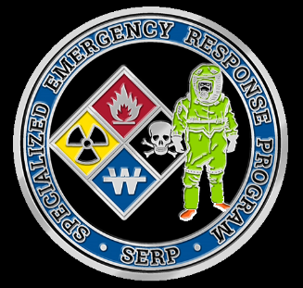**Specialized Emergency Response Program**

**of Whatcom County**

**Hazardous Materials Unit**

PO BOX 871, Bellingham, WA 98227

[serphazmat@gmail.com](mailto:serphazmat@gmail.com)

Phone (360)756-5020 Fax (360) 715-1851

***PUBLIC/PRIVATE***

***PARTNERSHIP***

**TEAM MEMBER APPLICANT PACKET**

ENCLOSED: Requirements and Forms

Each applicant is expected to participate for a minimum of three (3) years.

Applicant must have a high school diploma, or equivalent.

Applicant must be at least twenty-one (21) years of age.

Applicant must have a valid Washington State driver’s license.

Applicant shall not have been convicted of any felony.

Applicants should be available for response on a 24-hr., 7 days per week basis; with employment, vacation, etc. as an acceptable exception, with prior Team notification.

Prospective Team members shall have NFPA 472 Operations level certification (or Team accepted equivalent program) prior to applying.

Team members must complete a program meeting the current NFPA 472 Technician course.

Team members will be required to attend on-going training classes and drills. The attendance levels will be 80% as a minimum. (This will require approximately 40 hours per year).

Must certify with, and maintain, certification with SCBA used by the Team, as required by WAC 296-305.

Each Team member shall have a physical examination on an annual basis. This physical shall meet WAC 296-62-3050.

Must maintain medical requirements, and submit annual “fit-to-perform” statement, as per WAC 296-62-3050. The costs for this medical monitoring shall be born by the sponsoring agency or the individual if a non-affiliated member.

All Team members shall maintain such a level of physical fitness as to not jeopardize themselves or others during periods of extreme physical activity.

Each applicant shall submit a signed application, a signed Sponsoring Agency form, a photocopy of their Washington state driver’s license, and a report of a physical examination which occurred within the last twelve (12) months.

“Sponsoring Agencies” are Whatcom County fire districts, city fire departments, and private organizations which have signed the agreement that founded the Specialized Emergency Response Program, and maintain status as “voting members.”

A “non-affiliated member” is defined as a Team member or Team applicant, who chooses to accept the responsibilities of this sponsor. Some of the responsibilities that may be incurred are the costs of medical monitoring, special uniform costs, training costs, etc. A non-affiliated member shall sign the “Sponsoring Agency” form, and make obvious visible notation that this is a non-affiliated member.

All Team members shall follow all Operational Guidelines, and all policies adopted by the Board of Directors of the corporation.

Each Team member shall be issued various materials while a Team member; such as books, pager, and various equipment. Each member shall be expected to care for these materials and will be expected to cover the replacement costs if lost or damaged through abuse, neglect, or negligence. All Team materials will be returned upon separation from the Team.

Attached are the following forms: Team Member Application

Sponsoring Agency form

Fit-to-Perform Statement

Chuck Henkel

Specialized Emergency Response Program

Hazardous Materials Unit Team Leader