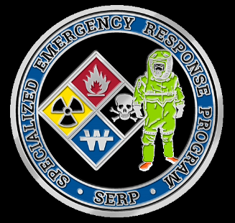**Specialized Emergency Response Program**

**of Whatcom County**

**Hazardous Materials Unit**

PO BOX 871, Bellingham, WA 98227

[serphazmat@gmail.com](mailto:serphazmat@gmail.com)

Phone (360)756-5020 Fax (360) 715-1851

***PUBLIC/PRIVATE***

***PARTNERSHIP***

**TEAM MEMBERSHIP APPLICANTS  
SPONSORING AGENCY STATEMENT**

Date: _____________________________

Sponsoring Agency: _________________________________________________

Name of Applicant: __________________________________________________

Has this person met the requirements for team membership as described in the “Team Membership Packet?”

As a sponsoring agency, there are required costs that your agency will incur:

* Initial and annual medical evaluations per WAC 305-05011 296.62 part p. Potentially on-going medical monitoring if an incident occurs.
* Potential overtime costs.
* Initial Hazardous Material Technician training and continuing education costs.

If you have any questions regarding your responsibilities as a sponsor, contact Chuck Henkel, Team Leader.

Signature of Representative: __________________________________________

Position/Title: ______________________________________________________

Date: _____________________________